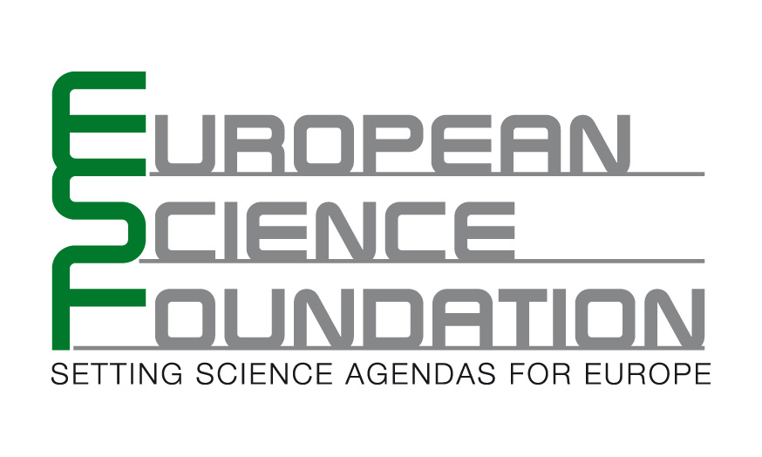 | Exploratory Workshop Scheme
 | Standing Committee for the Humanities (SCH)

ESF Exploratory Workshop on

Applying Semantic Web Technologies to Medieval Manuscript Research

Birmingham (United Kingdom), Monday 30 March – Wednesday 1 April 2009

Convened by:
Professor Wendy Scase ①, Dr Orietta Da Rold ②

① University of Birmingham (Department of English, University of Birmingham, UK)
② University of Leicester (Department of English, University of Leicester, UK)

Co-sponsored by

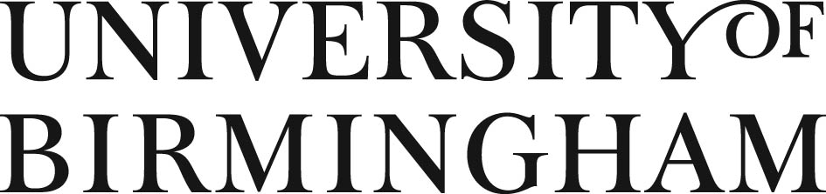

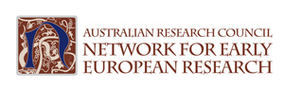

The European Science Foundation (ESF) is an association of 80 Member Organisations devoted to scientific research in 30 European countries. The Mission of ESF is to provide a common platform for its Member Organisations in order to advance European research and to explore new directions for research at the European level. Through its activities, the ESF serves the needs of the European research community in a global context.

The main objectives of ESF for the years 2006-2010 as defined by its current Strategic Plan are to promote Science Strategy and Science Synergy, paving the way for initiatives across disciplinary and geographic boundaries in the European Research Area (ERA).

The Exploratory Workshops scheme is one of the key instruments of the Science Strategy “pillar”. Each year, ESF supports approximately 50 Exploratory Workshops across all scientific domains. The focus of the scheme is on workshops aiming to explore an emerging and/or innovative field of research or research infrastructure, also of interdisciplinary character. Workshops are expected to open up new directions in research or new domains. It is expected that a workshop will conclude with plans for specific follow-up research activities and/or collaborative actions or other specific outputs either within the frame of ESF (e.g. prepare the ground to develop a Forward Look, a Research Networking Programme or a EUROCORES proposal; publication of a Policy Briefing…) or for submission to the EU 7th Framework Programme or to other European or international funding organisations.

European Science Foundation
1 quai Lezay Marnésia
BP 90015
67080 Strasbourg Cedex
France
Fax: +33 (0)3 88 37 05 32
http://www.esf.org

ESF Exploratory Workshops:

Farzam Ranjbaran
Scientific Coordinator

Valerie Allspach-Kiechel
Senior Administrator
Tel: +33 (0)3 88 76 71 36
Isabelle May
Administrator
Tel: +33 (0)3 88 76 71 46
Email: ew-office@esf.org
http://www.esf.org/workshops

Convenor:  Convenor’s Name Wendy Scase  Convenor’s email  W.L.Scase@bham.ac.uk | Convenor’s address  Department of English, University of Birmingham  Edgbaston,  Birmingham B15 2TT,  United Kingdom
Co-convenors:  Co-Convenor’s Name Orietta Da Rold  Co-Convenor’s email  odr1@leicester.ac.uk | Co-convenor’s address  Department of English,  University of Leicester  University Road, Leicester, LE1 7RH,  United Kingdom

Main Objectives of the Workshop

Medieval manuscripts are an important part of the European cultural heritage, and attract a significant body of active researchers. But the Web services devoted to these manuscripts suffer from major limitations, and are difficult to use effectively. The Workshop will systematically examine the potential of using research into Semantic Web technologies to address these limitations and to improve access to knowledge about these manuscripts for researchers and the wider community.

The specific goals of the Exploratory Workshop are as follows:
- Review the current situation in the provision of Web access to medieval manuscripts across Europe;
- Investigate specific areas and ways in which the needs of European researchers and the nature of their research questions are not being met by current Web services;
- Review the relevant research into Semantic Web technologies which are applicable to the cultural heritage domain;
- Identify areas in which these Semantic Web technologies have the most promise for addressing the limitations affecting medieval manuscript research;
- Set out a programme of potential future research activities in this field, including future meetings and publications;
- Draw up a plan for developing collaborative grant applications in this field.

Context of the Workshop
Among the greatest treasures in the cultural heritage of Europe are its medieval manuscripts. Many hundreds of thousands still survive today, in collections around the world, where they are intensively studied by researchers and admired by visitors to libraries, museums and art galleries. There are numerous Web sites and projects devoted to medieval manuscripts, originating both from research groups working on these manuscripts and from the cultural heritage institutions in which they are held.
But these Web sites and services suffer from several major limitations. There is a lack of integration and interoperability between the many different services, and it is difficult to find out systematically what research and digitization are being undertaken in collections around the world. The use of terminology and of descriptive standards is inconsistent and unsatisfactory, especially across different European languages and cultures. There is often a gap between the descriptions of the manuscripts and the reports of the research which has been based on them. As a result, European researchers still face major difficulties in finding, using and sharing knowledge about medieval manuscript collections.
This Exploratory Workshop aims to investigate how Semantic Web technologies can be applied to address these limitations. The Semantic Web encompasses a range of emerging technologies and standards designed to make digital content available for processing by Web-based software in a more intelligent way. The primary purpose of these developments is to enable knowledge to be found, shared and integrated more easily. The value of Semantic Web technologies for medieval manuscript research is potentially very significant indeed.
Several major European research projects are applying Semantic Web technologies to the cultural heritage domain, including MultimediaN in the Netherlands and CultureSampo in Finland. The Europeana digital library service is also working to include Semantic Web technologies. There are also a significant number of Semantic Web projects working at a much broader level, such the DBPedia project. But, to date, there has been no specific investigation or analysis of the applicability of Semantic Web technologies to medieval manuscript research.
The Exploratory Workshop is designed to bring together experts in the study and analysis of medieval manuscripts and experts in the application of digital technologies to cultural heritage collections. Participants include researchers with internationally recognized expertise in the study of medieval manuscripts, researchers with similar expertise in the application of Semantic Web technologies to the cultural heritage domain, curatorial staff from cultural heritage institutions, and experts in the development of Web-based services for cultural heritage.
The workshop will include participants from major collaborative national and international research networks with an interest in medieval manuscript research: the Medieval Manuscript Research Consortium (UK), the Australian Research Council’s Network for Early European Research, and CARMEN (Co-operative for the Advancement of Research through a Medieval European Network).
Participants will also include librarians who are active in the work of the Consortium of European Research Libraries (CERL) and its Manuscripts Portal project, as well as in the ENRICH project led by the National Library of the Czech Republic.
The Exploratory Workshop will be the first systematic exploration of this issue, and provides an opportunity to set the European research agenda in this field for the next three to five years and beyond.
Workshop Agenda
A Position Paper will be prepared and circulated in advance of the workshop. Each participant will then have an opportunity to make a presentation during the workshop in response to the Position Paper. Participants will be invited to provide an Abstract of their presentation before the Workshop, to be circulated in advance to other participants. It is hoped to provide the Position Paper and Abstracts in parallel translations in several languages as appropriate and practicable. Presentations will fall into three broad groups:
- Research questions: researchers working with medieval manuscripts will discuss the kinds of research questions they are addressing, and the extent to which existing Web services meet their needs.
- Web services: curators and technology experts involved in the delivery of Web-based services relating to medieval manuscripts will discuss the design and development of these services.
- Semantic Web and cultural heritage: researchers and technology experts working on the application of Semantic Web technologies to the cultural heritage domain will discuss the opportunities and difficulties experienced in their projects.
Participants will be invited to illustrate or supplement their presentations by displaying posters and/or distributing printed materials. The presentations by individual participants will be followed by an open discussion of future directions and actions, including:
- identifying funding opportunities,
- setting a research agenda; and,
- building collaboration between existing projects and services.

Report publication and dissemination
The Workshop Report will be published on the Web, via the Web sites of CARMEN (Co-operative for the Advancement of Research through a Medieval European Network) and NEER (Australian Research Council’s Network for Early European Research).

PRELIMINARY PROGRAMME
Monday, 30 March 2009
11.00-11.30 Arrival, Registration, Coffee
11.30-11.45 Welcome by Convenor
Wendy Scase (University of Birmingham, Birmingham, UK)
Welcome to the University of Birmingham Anne Pauwels (Head of College of Arts and Law, University of Birmingham, Birmingham, UK)
11.45-12.05 Presentation of the European Science Foundation (ESF)
tba Standing Committee for the Humanities (SCH)
12.05-13.00 Lunch
13.00-17.45 Afternoon Session: Research Questions in Manuscript Studies
13.00-15.30 Presentations on Specific Research Projects
Ian Johnson (University of St Andrews, St Andrews, United Kingdom), Brian Møller Jensen (University of Stockholm, Stockholm, Sweden), Ben Outhwaite (University of Cambridge, Cambridge, United Kingdom), Orietta Da Rold (University of Leicester, Leicester, United Kingdom), Francesco Lo Monaco (Università di Bergamo, Bergamo, Italy)
15.30-16.00 Coffee / tea break
16.00-17.30 Presentations on Specific Research Projects
Christian Müller (IRHT, Paris, France), Paul Bertrand (IRHT, Orléans, France), Wendy Scase (University of Birmingham, Birmingham, United Kingdom)
      - Dinner
19.30-21.30 Evening Session: Web Services and Medieval Manuscripts I
19.30-20.00 Presentation 1 “Manuscriptorium/ ENRICH”
Zdeněk Uhlíř and Karel Kucera (National Library of the Czech Republic, Praha, Czech Republic; AiP Beroun, Beroun, Czech Republic)
20.00-20.30 Presentation 2 “CERL Manuscripts Portal”
Ivan Boserup and Elmar Mittler (Det Kongelige Bibliotek, København, Denmark; Niedersächsische Staats- und Universitätsbibliothek Göttingen, Göttingen, Germany)
20.30-21.00 Presentation 3 “CERL Thesaurus File”
Claudia Fabian (Bayerische Staatsbibliothek, München, Germany)

Tuesday, 31 March 2009
09.00-10.30 Morning Session: Web Services and Medieval Manuscripts II
09.00-09.30 Presentation 1 “Manuscript Portal”
Michael Pidd (University of Sheffield, Sheffield, United Kingdom)
09.30-10.00 Presentation 2 “Digital Special Collections”
Saskia van Bergen (Universiteit Leiden, Leiden, Netherlands)
10.00-10.30 Presentation 3 “Commercial Database Services”
Simon Forde (Brepols NV, Turnhout, Belgium)
10.30-11.00 Coffee / Tea Break

11.00-12.30 Morning Session: Applications of Semantic Web Technology
11.00-11.20 Presentation 1 “Semantic Web and the Cultural Domain”
Antoine Isaac (Vrije Universiteit, Amsterdam, Netherlands)
11.20-11.40 Presentation 2 “Semantic Web and Classical Studies”
Cristina Vertan (Universität Hamburg, Germany)
11.40-12.00 Presentation 3 “Semantic Web and Medieval Studies”
Toby Burrows (University of Western Australia, Perth, Australia)
12.00-12.30 Questions and Discussion
12.30-13.30 Lunch
13.30-17.30 Afternoon Session: Planning Follow-up Activities
13.30-13.45 Presentation 1 “Aims of the closing session”
Wendy Scase, Orietta Da Rold, Toby Burrows (University of Birmingham, Birmigham; United Kingdom, University of Leicester, Leicester, United Kingdom; University of Western Australia, Perth, Australia)
13.45-15.30 Discussion of relevant funding opportunities, follow-up activities, networking, collaboration
15.30-16.00 Coffee / tea break
16.00-17.30 Further discussion; listing of action points
18.00-18.50 Reception sponsored by the University of Birmingham School of English,
Drama, and American and Canadian Studies; address by Judith Petts (Pro- Vice-Chancellor for Research and Knowledge Transfer, University of Birmingham)
19.00-20.30 Dinner

Wednesday, 1 April 2009
      - Breakfast
End of Workshop and departure

European Science Foundation

Objectives of the ESF Standing Committee for the Humanities (SCH)

The main tasks of the ESF Standing Committee for the Humanities (SCH) are:
- to encourage interdisciplinary work through the independent evaluation of collaborative research proposals emanating from the scholarly community;
- to identify priority research areas and to play an integrative and co-ordinating role by creating links between research communities which in the Humanities are often small and fragmented.
- to contribute to the development of the ESF science policy agenda and to provide expert advice on science policy actions at the European level in the field of its responsibilities.
The Committee is well aware that the ESF is the only European Agency where the Humanities have a place next to the other sciences and where European projects are reviewed, developed and subsequently operated.
The Committee considers it all the more important to be heard as the voice of the Human Sciences in Europe and to continue pleading for a more prominent place for the Humanities in the European landscape.

ESF Humanities Unit:
Nina Kancewicz-Hofman  Head of Unit | Irma Vogel  Senior Administrator
Marie Suchanova
Administrator
Tel: +33 (0)3 88 76 71 83
Email: humanities@esf.org
http://www.esf.org/human

